Enter password to gain access
Try 1:
Attempt | Input | Expected | Actual | P/F
1 | (Nothing) | Invalid input | Invalid input | P
2 | test | Invalid input | Invalid input | P
3 | 21 | Invalid input | Invalid input | P
4 | N/A | Program end | Invalid input | P

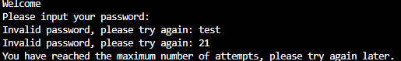
Try 2:
Attempt | Input | Expected | Actual | P/F
1 | Password123! | Access granted | Access granted | P
2 | N/A | Options menu | Options menu | P
3 | N/A | N/A | N/A | N/A
4 | N/A | N/A | N/A | N/A

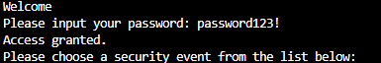

Option 1 – Security Event Counter:
Attempt | Input | Expected | Actual | P/F
1 | (nothing) | Fail | Fail | P
2 | Fake password | Fail | Fail | P
3 | Fake password | Fail | Fail | P
4 | Fake password | Fail | Fail | P
5 | Fake password | Fail | Fail | P
6 | Real password | Pass | Pass | P
7 | Fake password | Fail | Fail | P
8 | Real password | Pass | Pass | P
9 | Fake password | Fail | Fail | P
10 | Real password | Pass | Pass | P
11 | N/A | 70% fail | 70% fail | P

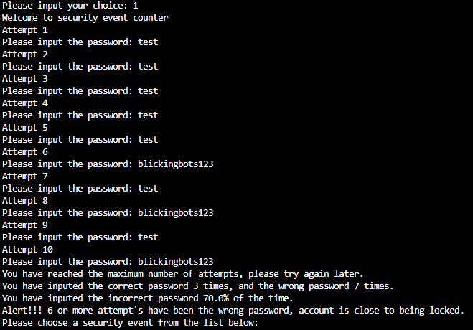

Option 2 – Brute-Force Simulation:
Try 1:
Attempt | Input | Expected | Actual | P/F
1 | (blank) | Invalid password | Invalid password | P
2 | Fake password | Invalid password | Invalid password | P
3 | Fake password | Invalid password | Invalid password | P
4 | Fake password | Invalid password | Invalid password | P
5 | Fake password | Invalid password | Invalid password | P
6 | (blank) | Invalid password | Invalid password | P
7 | (blank) | Invalid password | Invalid password | P
8 | (blank) | Invalid password | Invalid password | P
9 | (blank) | Invalid password | Invalid password | P
10 | (blank) | Invalid password | Invalid password | P
11 | N/A | Options menu | Options menu | P

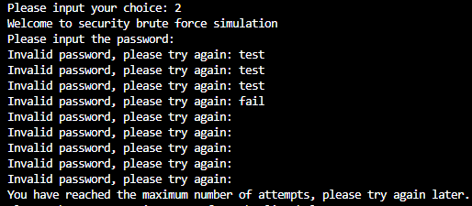
Try 2:
Attempt | Input | Expected | Actual | P/F
1 | Real password | Access granted | Access granted | P
2 | N/A | Options menu | Options menu | P

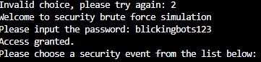

Option 3 – login authentication:
Try 1:
Attempt | Input | Expected | Actual | P/F
1 | Fake User and fake password | Invalid user and password | Invalid user and password | P
2 | Fake User and fake password | Invalid user and password | Invalid user and password | P
3 | Fake User and fake password | Invalid user and password | Invalid user and password | P
4 | N/A | Options menu | Options menu | P

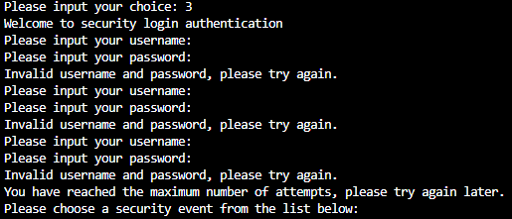
Try 2:
Attempt | Input | Expected | Actual | P/F
1 | User and password | Access granted | Access granted | P
2 | N/A | Options menu | Options menu | P

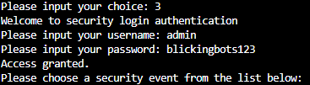

Option 4 – Exit program:
Attempt | Input | Expected | Actual | P/F
1 | 4 | Program end | Program end | P

